***School of Electronic Engineering and Computer Science***

***Queen Mary University of London***

ECS514U Design and Build Project  
Group 4 Final Report

Session 2021-2022

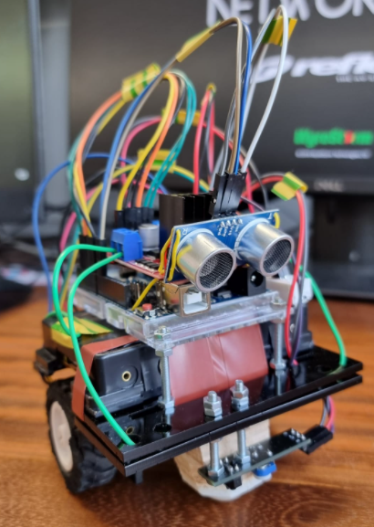

**GROUP 4** **MEMBERS:**

Muhammed Amir Hamzah, 200391353, ec20470@qmul.ac.uk

Shuaib Mohamed, 200929226, s.mohamed@se20.qmul.ac.uk

Hassan Nur, 200435624, hassan.nur@se20.qmul.ac.uk

Muaaz Sand, 200448554, m.sand@se20.qmul.ac.uk

Harikrishna Soni, 190284956, h.soni@se20.qmul.ac.uk

**GROUP LEADER:**

**Muhammed Amir Hamzah, 200391353,** [**ec20470@qmul.ac.uk**](mailto:ec20470@qmul.ac.uk)

**Contents**

**Abstract** 3

**Introduction, specifications, background** 4

Introduction 4

Understanding of the aims of the project 4

Placement in context of literature on the topic 5

Clarity of specifications 6

User requirements 6

Input/Output Requirements 7

Operational requirements 7

Functional requirements 8

Constraints 9

**Design** 11

Achievement of basic aims 11

Systems 11

Movement 11

Control Movement 13

Detect Enemy 14

Detect the Black and White Ring 15

Create Skeleton 17

Logic 20

Ambition of goals (level of difficulty and innovation 22

Quality and completeness of the work 22

**Analysis, testing, results, and discussion** 24

Adequacy of testing 24

Documentation of testing 24

Testing Movement 24

Testing enemy detection 28

Testing Black and White detection 31

Logic Testing 33

Critical analysis of results 34

Testing User requirements 35

Analysis of strengths/weaknesses 36

Possible further work 38

Outer body designs 38

Hardware components 38

Remote-controlled sumo 39

**Sources** 40

Research sources 40

System Diagram 41

Full Code 42

# **Abstract**

The objective of this project is to design, build and test a mini-sumo robot, which will compete in a sumo robot competition.

The main features of the system are:

* Recognize other robots in the ring
* Avoid moving out of the ring
* Pushing enemies out of the ring

The robots are placed in a head-to-head match with the objective of forcing the opponent out of the ring. The designed robot should be able to detect another robot in the ring and should also be able to identify between the colours black and white to navigate around the ring. Its goal is to be the last robot standing in the ring through a combination of defense and attack.

This report deals with the design approach, theory of operations, specifications, cost, and procedures followed to create this mini-sumo robot.

# **Introduction, specifications, background**

## Introduction

Robot Sumo is a sport that involves having participants design, build and program a robot that will compete with others in a Dohyo (ring) to push each other off the ring through sheer force and an algorithm should the participant(s) choose to program one.1

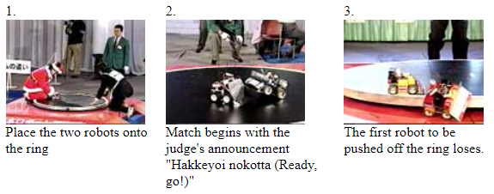

Figure 1 : from the FSI-Japan specification

The sport was conceived through a tournament, which was founded by the then-president Hiroshi Nozawa, leading the company Fuji Soft at the time. The idea behind it was to encourage young people to develop technology and robotics through a certain philosophy.

The specification we as a group were told to follow was the mini specification, which limited us to a width and length of about 10cm or less and a weight of 500g or less. As such, we had to devise ways to best build the robot in a way that allowed for as much robustness, combat edge and modularity as possible all while meeting the requirements of the specification.

Throughout the duration of the module, we have endeavored to meet the goals we have set ourselves through the allocation of crucial skills and expertise to each facet of the project and have made it a priority to consistently make progress at certain milestones but not without roadblocks and/or pitfalls incurred by various causes.

Potential customers could be younger people or children who would enjoy an automatic robot for its novelty or entertainment purposes. Finally, another target for our project would be other engineers or designers who would try to iterate and branch off our design.

## Understanding of the aims of the project

We understood that there were 2 key phases of this project.

* Design and implementation of a motorized and automated vehicle that will be able to move within a restricted area and identify and push and object
* Aim for the win

The aim is to design and create a robot that will participate in such a competition and win by pushing the enemy robot out of the ring. Our robot should be able to navigate around the map alongside detect the enemy robot. We set many objectives and milestones to achieve these.

Our robot must be able to move around the ring, turn whilst moving around, see what colour the floor is, and see where the enemy is. If it can sense the floor is white, then it should know that it is at the border and move to go back towards the black area. If its sensors pick up another robot in the ring with it, then it should immediately move to pick up speed and push the enemy off the ring.

From this we set out a series of objectives. This included reviewing past models based on previous competitions and sumo robots/engineer enthusiasts who had completed similar work. There was also high importance on the preferred components, the interface, the suitable design construction for both defence and offense.

## Placement in context of literature on the topic

The first sumo robot competition began in Japan in 1989. Since then, sumo robot competitions have grown dramatically both in Japan and globally. In 2001, the number of robots that entered the Japanese competition was over 4,000.

Despite having different requirements/design specifications when competing e.g. being able to attach attacking mechanisms, they have the same concept – create an autonomous robot that can stay in the ring and knock their opponents. This competition has different levels of complexity. In our case it was a 1-hour competition after 12 weeks. However, in Japan, this competition is on a bigger scale as the competition goes carries over and continue from Thursday to Monday. There have also been various versions. This was aimed at IEEE students who were in college and has developed from there onwards.

Since this is an international competition, there have been many previous models. This allows us to gain an insight into what is a good and bad idea. It also helps us understand the results of other people carrying out test of what we wanted to carry out.

Below is an example of 2 finalists in Lithuania competing in this competition

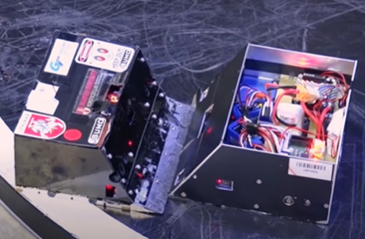

Figure 2 : 2 robots fighting in the league

Although the requirements were slightly different (e.g. 3kg weight), we saw that these 2 designs proved to be better as this style of design progressed the furthest in the competition. We notice how the shape of the chassis was not too tall which provided a more compact design with high stability. The ramp is also a key feature as this was used to push opponents off and defend itself simultaneously. One smaller feature was the use of screws. This was key and something we used in our design as it beneficial for adjustments and carrying out diagnostic tests.

## Clarity of specifications

### User requirements

The goal of the user is to ram into an enemy robot and push it out of the ring whilst adhering to the rules, those being waiting for the mark of the referee and not bypassing the arena. Certain user requirements had to be met to ensure that our robot can compete.

Weight

Weight was one of the major requirements that had to be met. The design and the components we selected had to ensure that the weight must not exceed 500g.

#### Cost

The budget was required to be below £100, however at the same time we had to ensure that the quality of our robot was not compromised whilst also keeping a portion of the budget for any backup parts.

#### Durability

The robot was expected to withstand the roughness associated with the game for a long duration of time so the design of the robot and the materials chosen should ensure that it's durable and structurally sound.

#### Portability and simplicity

The robot needed to be portable enough so that the user can carry it from one position to another easily and the design of the robot should not be complicated but is able to complete the intended task effectively.

#### Sensors

Sensors needed to be used efficiently so that our robot could sense impact from every direction, differentiating between frontal impact and impacts from the side or rear, as well as detecting the sumo ring’s boundary line (It must react to these stimuli intelligently).

#### Preset motions

The robot was required to move in preset motions depending on the circumstance: search and attack (detect and charge at the enemy robot attempting to push it out of the ring), search and run (detect enemy robot and run away which is useful when overpowered by the enemy robot).

#### Performance

The robot should be quick, smart, agile and have enough torque to be able to hold its ground against and beat another robot that is also quick, smart, and agile.

#### Size

The robot was required to have a standard size of 10cm x 10cm, however, there was no restriction on the height.

### Input/Output Requirements

1. An input that we were looking for according to the project aims is the colour of the floor, we required infrared sensors on both the front and back of the robot pointed toward the floor and calibrated so that if the front sensor identifies black, then the whole robot should reverse, and if the back sensor identifies white, then the entire robot should accelerate forward.
2. Another input requirement that we considered was detecting the enemy robot. We decided to use an ultrasound sensor, at first, we thought of using a camera sensor but decided against it due to the complexity of designing a system that can differentiate between an enemy robot and other background noise whether it be flashing lights or other people walking around behind the enemy robot but still in view of the camera.
3. Outputs we needed to consider were the signals we sent to the wheels. Depending on the situation, there were four parts that we needed to control – Acceleration, deceleration, movement, and rotation.
   1. For example, if the rear infrared sensor reads white, the wheels should immediately accelerate to stay in the ring, or if the ultrasound sensor in the front detects something in its range, the wheels should accelerate to ram into it at full power.
   2. Regarding deceleration, we would need to bring the robot to a complete halt should it not detect the enemy.
   3. Regarding movement (the speed at which the robot is moving), a situation in which we would need rapid movement is when the enemy robot is spotted, and we want to build momentum to ram it at full speed. A situation where would use a slower speed is when we would want to save power in our sentry mode where the robot is patrolling the ring, looking for an enemy, though again due to the small size of the ring and brief time of the matches, we see no reason to prioritize.
   4. Lastly regarding rotation, we need a system to rotate the entire chassis on a single axis so that the robot can turn whilst driving, this would be necessary for moving to the designated points in the ring or moving towards the enemy whilst the enemy is also moving.

### Operational requirements

The robot was required to have a few distinct modes of being that it should constantly be in or switching between.

1. Normal operational mode: The robot can navigate around the map and detect the enemy robot. Benchmarks can be utilized to ensure that the robot is functioning correctly in this mode.
   1. Line detection: Create an identical circular sumo ring and test if the infrared sensors are working by checking if the robot can move between the certain points on the ring.
   2. Enemy detection: Determine if the robot can detect an opponent by placing an object in front of it.
2. Sentry mode: Potential alternative to the normal operational mode. The robot will move in a preset pattern such as a guard patrolling an area until it senses an enemy in which it transitions into the attack mode.
3. Attack mode: When the ultrasonic sensor detects an enemy, we should get a numerical value for the enemy’s relative distance and use this value to decide the speed at which our robot approaches it. If the enemy is far away, it should pick up speed and attempt to push the enemy off with one explosive motion. If the enemy is close, the robot should slowly build up speed to attack it.
4. Self-test/maintenance mode: The robot could move in a circle of a radius of 5cm. Maintenance could be carried out by manually driving the robot to test whether it responds to a given instruction.
5. Fail safe mode: The robot could halt and rotate to face the center of the arena should it drive too close to the edge of the arena. If the ultrasound sensor is damaged (meaning that the object detector is not working) another fail safe preset motion could be used that can implement random movement.

### Functional requirements

1. The robot should perceive the black arena as a safe zone to maneuver and the white zone as a danger zone using the infrared sensor. It should move accordingly, accelerating towards the opponent should it be within range. This can be achieved by tying the instructions the robot follows to the values of the given colour detected.
   1. An IR sensor does not view the colour, they differentiate using reflectivity (they sense the reflectivity of any object in view), different colours reflect different wavelengths, which is how colours are created on the visible light spectrum. Darker colours are better at absorbing IR, and bright colours are better at reflecting it, so we can easily distinguish between black and white because their values would be on opposite sides of the same spectrum.[11]
   2. If the value given by the front IR sensor indicates a value that represents white, it should immediately reverse. If the value given by the back IR sensor indicates white, then the robot should move forward back into the black area.
   3. To be consistent with the points above, the robot should have two statuses: when it is fully in the black area so that it does not have to activate evasive maneuvers, and a “panicked” status where the robot attempts to enter the black area again.
2. The robot should be able to perceive the opponent and the distance between them using an ultrasound sensor. As a result, the robot will focus on the opponent while carrying out the appropriate movements necessary to get a positional advantage should it be feasible or to rush into the opponent and move them out of the arena. This can be achieved by giving the robot the distance in centimeters at which it detects the opponent using ranges (I.e., rush into the opponent when both robots are 20cm apart).
   1. Ultrasonic sensors work by emitting sound waves at a frequency above human hearing, they then wait for the wave to be reflected and use the time taken to calculate the distance. The ultrasonic sensor we use might give us our distance in meters, but on the off chance it does not, in our program we will need to translate it using the formula {Distance = ½ * Time * speed of sound} [12]

### Constraints

1. Cost: The budget was only around £100 so the materials and parts ordered should be within the set limit and as cost efficient as possible. We also had to set aside funds in advance for any unforeseen circumstances such as broken components.
2. Time: The design and construction time was only 1 semester, so the design and functions chosen to be implemented should not be too complicated to be achievable within this timeframe. This also means that delivery time should also be accounted for when ordering components.
3. Weight and size: The weight of the robot is required to be under 500g, and the dimensions of the robot should not exceed 10cm^2. So, the components should be chosen carefully to achieve these requirements and be able to remain competitive despite such restrictions. If during the creation we are near our weight limit, we may ditch the chassis.
4. Power source: Components must be chosen based on the power output of the source (12v battery). The standby time of the battery should be durable enough to power the robot throughout the competition. We must also consider the ratio of power to weight, overall, we would prefer more power, but we must make sure that does not cause us to surpass our weight limit.
5. Scalability: We plan to use off-the-shelf components to create the robot, the only custom component that we may use would be our chassis and laser cutting.
6. Sustainability: The components and materials chosen will all be off the shelf parts, we do not plan to use proprietary technology, thus, once the project is over the device can be disassembled and reused. Our materials are expected to be sustainable; we must ensure that most of it can be recycled or used for other purposes rather than being dumped. We must also take the power source into account, by using a lithium-ion rechargeable cell, we can make sure that we will not need to discard used alkaline batteries potentially in an unsafe and polluting manner.
7. Interaction: A constraint for the overall project is that there will not be any interaction with our robot during the sumo fight, so we must program the logic to be self-sustaining.

# **Design**

## Achievement of basic aims

### Systems

Before we started buying the components, as a group we researched the different sub-systems that would make up our robot sumo system, we decided that our design specification mainly guided us towards two subsystems, a movement system, and a sensor system.

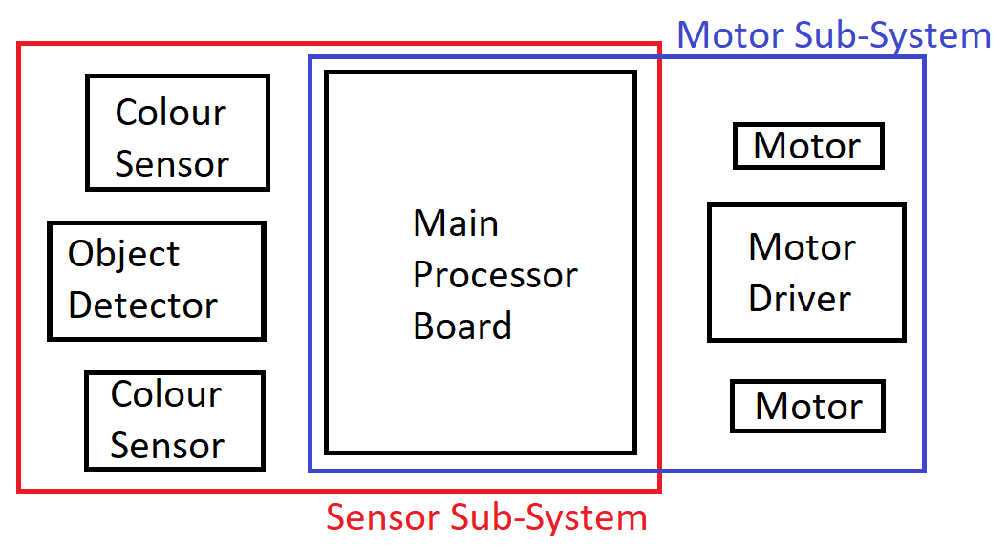

Figure 3 : Our sub-system map, pre-ordering our components

After we knew our subsystems, it was simpler to research and buy our components, our thought process for which, will be discussed later.

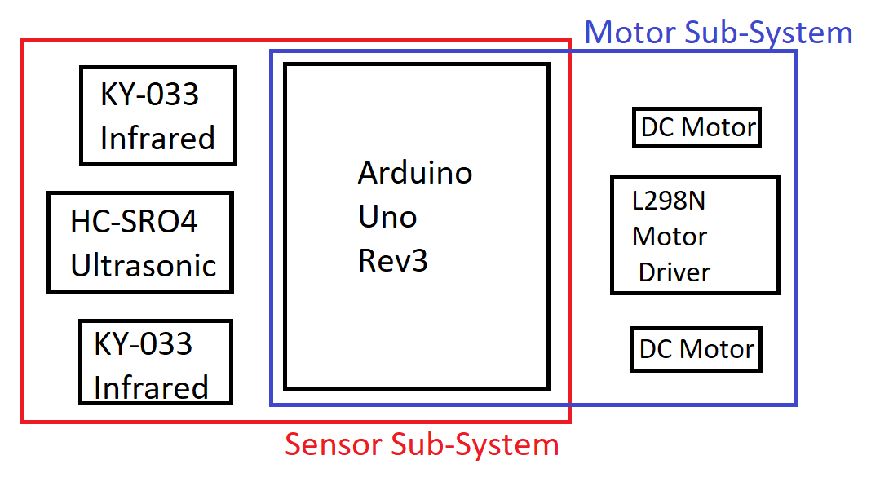

Figure 4 : Our sub-system map, post-ordering our components

### Movement

In order to move our robot, we are using a wheeled system similar to a car, our first decision was to choose the wheel layout we were to use. The two choices we thought of were a 4 wheeled design or a 2 wheeled design.



Figure 5 : 4 Wheeled vehicle

The benefits of using a 4 wheeled design is stability, it will grant us some protection against being tipped over, and having power spread over a wider area will allow our robot to have a more even output of power throughout the whole chassis.

The downsides of having 4 wheels is that it means that we will also have to have 4 motors, this will contribute greatly to our overall weight and will likely mean we have to scale down the power of our individual motors.

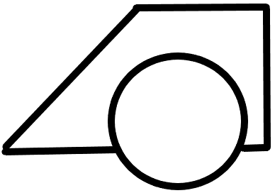

Figure 6 : 2 Wheeled vehicle

The motor we decided on after scouring Rapid Electronics and RS Components was the RS PRO DC motor (RS-238-9715). We chose this motor due to its specifications, from the data sheet, we know that it is built to run using a voltage of 6V to 15V. This is ideal because we intend to use a 12V power supply but might have to switch in the future and this will give us a cushion area. The advertised output speed is 10668 revolutions per minute, this is a good speed for this project and will hopefully give us a raw power advantage over our opponents even though it is heavier and consumes more power.

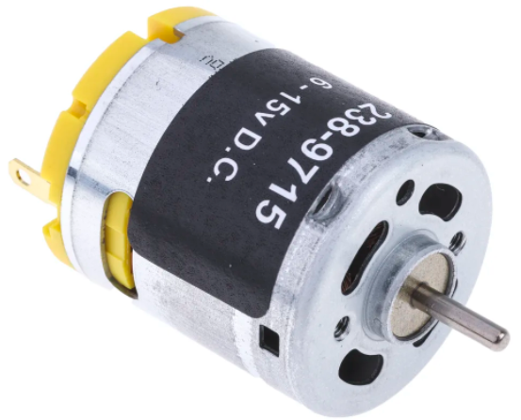

Figure 7 : RS PRO DC motor

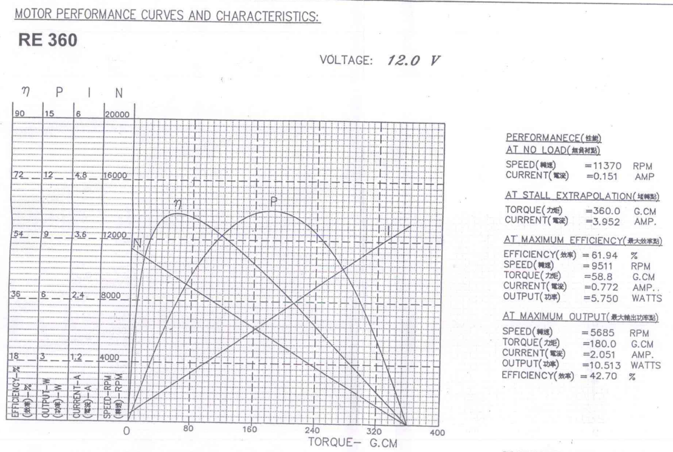

Figure 8 : Datasheet for our motor

Looking at the included data sheet provided with our motor, we find that even if we don’t supply our motor with the maximum voltage it can handle, it runs most efficiently at 62% so even if we supply the motors only 9 volts, it should run adequately.

### Control Movement

To control movement via the motors we couldn’t do it straight from the power supply or Arduino because we couldn’t maintain fine control of each wheel, we opted to buy the L298N.

From our research we decided on this component because it was seen as the industry standard for controlling multiple motors and it could supply up to 12 volts to the motors, more than the Arduino could.

Using this component we can control the direction of the motors through the code, rather than having to change the polarity of the power supply.

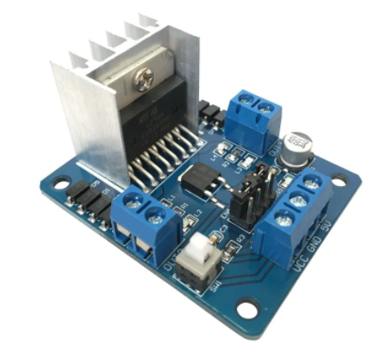

Figure 9 : L298N motor driver

There is a voltage drop off in the L298N from the power to the motor, about 2v due to the switching transistors in the H-bridge.

The component works by assigning forward and backwards to two motors, and 2 more pins for controlling speed.

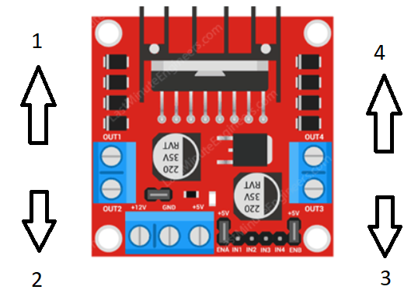

Figure 10 : Birdseye view of the L298N

So first we had to decide what side of the L298N counted as the “front”, I chose 1 and 4 because then the power cables would be coming out the back, which would help with cable management later.

The enable pins (A and B) can take analogue values from 0 – 255 which allows the Arduino to control the voltage that goes to the motor, which in turn controls the speed the wheels spin.

### Detect Enemy

To detect the enemy in the ring, we needed to include a sensor able to detect and measure the distance that enemies are away from it.

In the beginning whilst researching components, we came across an infrared motion sensor, but through researching other people who have made projects like this before, we found that it was far more common to use an ultrasonic sensor and from looking through example sumo robots, we found that the standard component for this job was the HC-SR04.

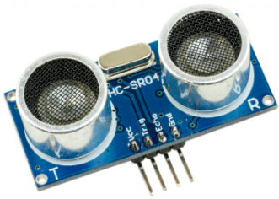

Figure 11 : HC-SR04 ultrasonic sensor

The way the sensor works is that it emits an ultrasound at 40kHz which will bounce off objects in its path and bounce back to the module, it will then calculate the travel distance by using the time taken and the speed of sound.

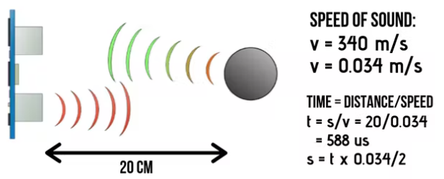

The way the Arduino can take advantage of the sensor is by generating an ultrasound wave by toggling the TrigPin, in which we turn it LOW for a short time (2 microseconds) and then turn it HIGH for 10 microseconds, generating an ultrasound wave, we can use the pulsein() function which will then read the time taken to receive the wave bounce, this will give us the time, then we can use the formula to calculate the distance between the object and the sensor in centimeters.

$$Distance=Speed ∙Time$$

$$Distance=\frac{Duration ∙0.034}{2}$$

The equation has been divided in half as we only need to consider the distance travelled to receive a signal.

The Data sheet for the HC-SR04 tells us that it has an effective angle of 30° and a ranging distance of 2cm to 400cm, so we need not think that the specifications of the sensor will become a bottleneck for the project as a whole.

### Detect the Black and White Ring

One of the key aims for the project was to be able to stay on the stage. This is done by sensing the different colours on the stage floor, black and white. In order to do this, we researched different sensors capable of recognizing colour.

The way in which an ultrasonic sensor works is that it does not really see colours. It instead senses the reflectivity of whatever is in front of it, with different colours having different wavelengths on the visible light spectrum. Darker colours are better at absorbing IR, and bright colours are better at reflecting it, so we can easily distinguish between black and white because their values would be on opposite sides of the same spectrum.

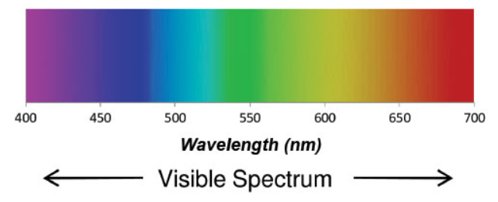

Figure 12 : The wavelength of different colours on the visible light spectrum

Since we needed to detect the colours black and white (because of the stage), we settled on choosing an infrared sensor. From our research we settled on two options.

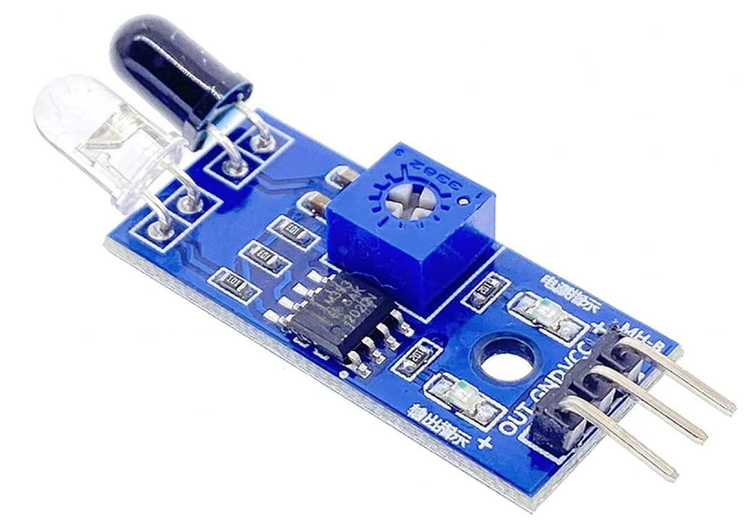

Figure 13 : Infrared PIR sensor

We found the Infrared PIR sensor and the KY-033 Infrared sensor. Due to having an abundance of budget remaining from ordering other components, we decided to order both sensors and using the one that best fit our use case.

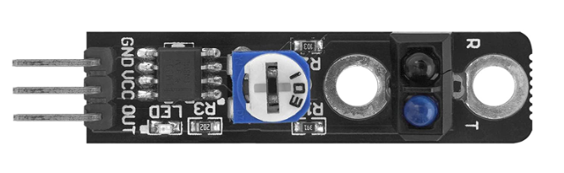

Figure 14 : KY-033 Infrared sensor

The first one we tried was the Infrared PIR sensor, when we connected it to the Arduino and read the data it provided, it returned a value of 5 when it detected white, and 8 when it detected black. The second one, the KY-033, when connected to the Arduino and read from the analogue pins, it returned a far greater range of values.

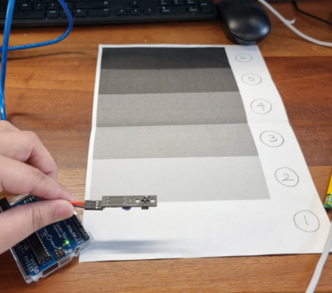

Figure 15 : Testing the infrared sensor

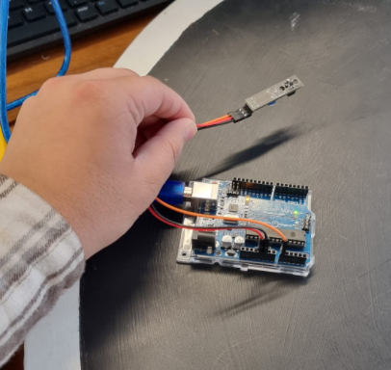

Figure 16 : testing infrared sensor on black section

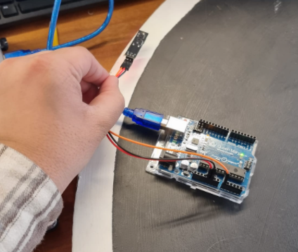

Figure 17 : testing infrared on white section

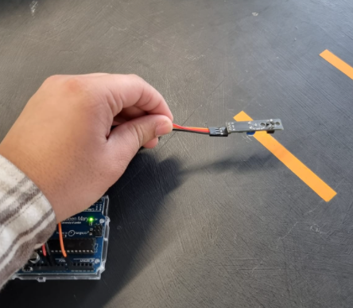

Figure 18 : testing infrared on yellow section

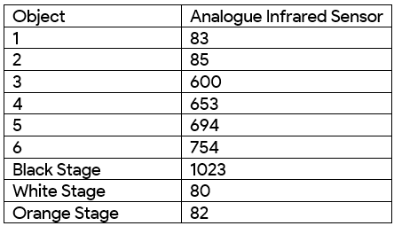

Figure 19 : results of testing the infrared sensor

From our initial testing we found that the KY-033 allowed us a far greater level of control and data compared to the alternative, due to this, we opted to use the KY-033 and returned the Infrared PIR sensor.

### Create Skeleton

From our research we found that there were only three realistic options for our robot’s chassis: a premade chassis available to buy online; a 3d printed chassis; and a 2d laser cut skeleton.

The benefits of using a premade chassis is that we can save time, we won’t have to spend time designing or modelling a chassis and we’ll have a decently made chassis that is almost guaranteed to work for our use-case, the downsides of this is that we will be severely limited in customizability, if we ever need to mount or other components later on in the project, there is a large chance that we will just not be able to whilst also keeping within the project restrictions of 10cm x 10cm and 500g. Another downside is the cost, a premade chassis is expensive for its size and will cause a sizeable strain on our budget.

The benefits of 3d printing our chassis are that we have ultimate control over every single area of our chassis, the possibilities really are limitless, and our product would be good quality, structurally sound, and infinitely customizable. The downsides of 3d printing are that it requires someone skilled in a CAD (Computer Aided Design) software to even edit online open-source designs, let alone create our own one from scratch. Another downside of 3d printing is the cost, the cost for printing in the electronics lab is £3 per printing hour, considering the size and complexity of our design, we would be spending at least 7 hours, therefore £21 on the component.

Another downside of 3d printing is that after we have printed our initial design, we will be locked into our chassis, any design changes we want to make will be extremely restricted and unstable. If we want to make any significant changes to our design, even something like mounting a sensor differently, we will need to print a new chassis which will add to costs. 3d printing is generally a great choice for rapid prototyping ideas, but for the high costs in this project, it is unfeasible.

The benefits of 2d laser cutting are like 3d printing where we have a high level of customization with our design, our only limitation is the 2d plane we are restricted to, but we can somewhat overcome this by using a stacked design. Another benefit of 2d laser cutting is the cost, by buying a single large sheet of a strong material, for example 3mm acrylic, we would have the freedom to quickly and rapidly prototype out different designs and adapt our chassis if we ever had an unforeseen complication in the future.

Another benefit of 2d laser cutting is the skill required, the design of a 2d laser cuttable file is far easier than 3d, by using a simple beginner software such as Inkscape, anyone from our team can easily create the necessary designs accurate to the mm. Though, a downside to using 2d plates as compared to a 3d block, is that stacking them and having to secure them together will be less secure compared to the single block that 3d printing offers.

After arguing the pros and cons of each chassis method, our team eventually voted for a 2d laser cut chassis, using 3mm acrylic and a stackable modular design. We chose 3mm as opposed to 5mm acrylic because 5mm was too unnecessarily thick and heavy, and opposed to any form of wood because of wood’s lower rigidity.

We started by drawing out the skeleton using pencil, being sure to stay within 10x10cm border. Then using the program Inkscape, we used the mm grid to draw out an initial design.

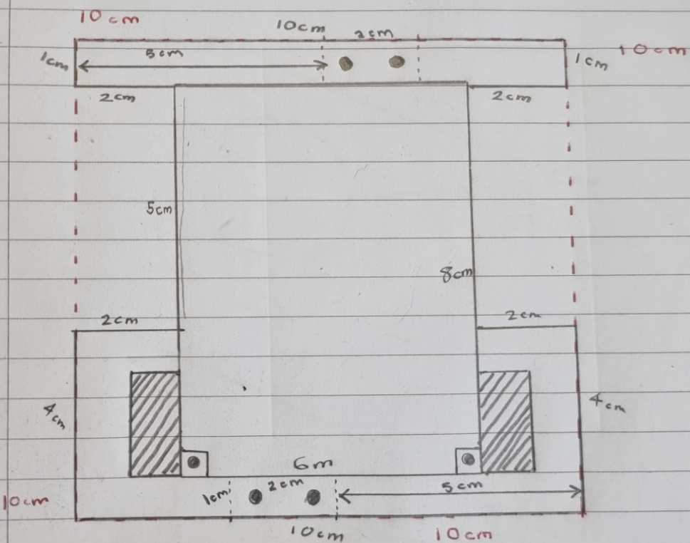

Figure 20 : pencil drawing of the skeleton

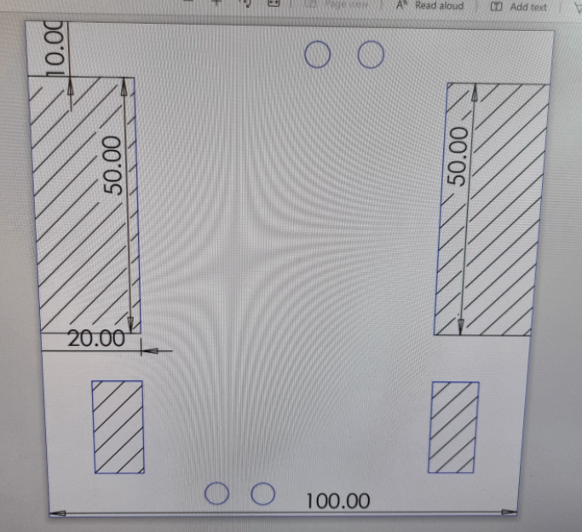

Figure 21 : Inkscape model of the skeleton

Then using the electronics lab’s specification for the laser cutter, where the lines to cut must have a red value of 255 and the lines, to emboss must have a blue value of 255. We also had to reduce the thickness of the line to match the tip of the laser cutting machine - 0.05mm.

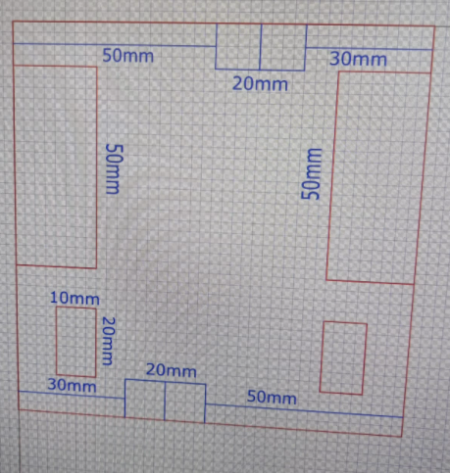

Figure 22 : Inkscape model of skeleton with laser cut specifications

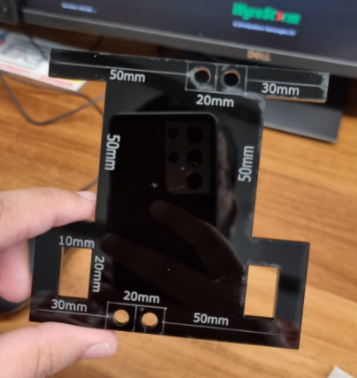

Figure 23 : Our first laser cut sample

After we printed the design and agreed on the efficacy of the laser cut design, we set out on designing a stackable design, so we would need a section to hold the Arduino and L298N, a section to hold the battery, and a section to hold the motors, including the part we had just made, we would also need to design and cut two more chassis piece, so again we designed it in Inkscape (below).

We added lots of long strips running throughout the entirety of the skeleton to reduce weight, and to allow us freedom to mount the Arduino as we saw fit and to have ample space to thread our wires throughout the system.

Another benefit of this design is that our entire device was modular, meaning we could disassemble it and work on separate components easier. The motors, the battery and the Arduino were completely able to be disassembled, allowing us to easily diagnose problems we would have later on without causing permanent damage to our device.

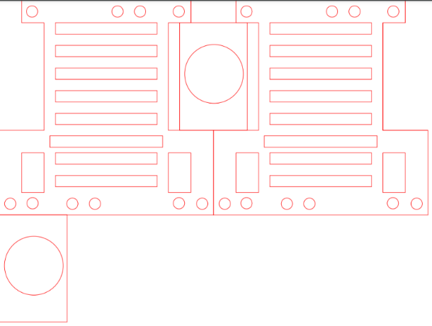

Figure 24 : More layers of our laser cut skeleton

### Logic

The logic patterns that the robot should follow represents the brain of the sumo, as a team we went through multiple different models displaying different methodologies we could take to tackle this project, after deliberation we narrowed our options down to three possible options-

#### Aggressive State

This methodology is best represented as our robot actively roaming around the ring, actively looking for the enemy in order to pounce upon them at full power. In this mode, we set the sensor reaction distance to 38, allowing our robot to react to the enemy anywhere on the stage, when it does detect the enemy, it should increase power to the wheels to their maximum power in a destructive charge to build up as much momentum as possible.

The benefit of this mode is that it allows us to build up the most momentum to collide against our enemy, but the downside is that we consume more power, and the more our robot moves around, the more likely it is to fall off the ring or be attacked from its blind spot.

#### Defensive State

This methodology is best represented as our robot passively staying in place or limiting movement and then using our weight and power in order to only react against enemies actively attacking us. In this mode, we set the sensor reaction distance to 10, allowing our robot to react to only immediate threats right in front of the robot, when it does detect the enemy at less than 5cm, we treat our robot as if it has already collided with the enemy and give the robot progressively more power in order to win the reverse tug of war with the enemy.

The benefit of this mode is that we preserve power, but also this allows us to leverage the power of our weight in order to stay in place and absorb the enemy’s charge. The downside of this mode is that if we are attacked from the blind spot of our ultrasonic sensor, then our robot will offer no resistance until it reaches the white border which is risky because the enemy may have built up momentum by that point.

#### Sentry State

This methodology is best represented as a compromise between aggressive and defensive, in this situation, our robot has a set path that the robot will constantly. So similar to aggressive mode it will be looking around the stage for the enemy, and similar to defensive mode, it will only react to enemies that are close to it.

The benefit of this mode is that since we are constantly moving around, it is hard to be caught from our blind spot and be pushed out without offering any resistance. The downside of this approach is that since the detection distance is smaller, we will have built up less momentum and so we have less impact force against the enemy.

After considering all these options, our group voted to use the defensive state logic due to us being able to leverage our weight to the maximum. Also, it allows our code to be simpler and therefore has less chance of failing us in the match.

Using this logic, we constructed a flowchart which will guide the creation of our code later.

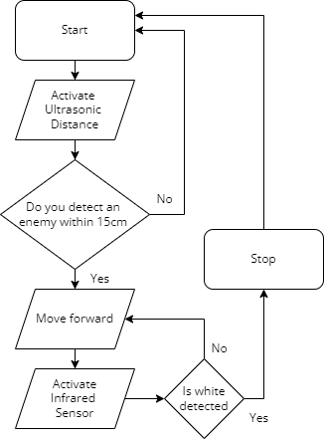

Figure 25 : flowchart for logic

## Ambition of goals (level of difficulty and innovation

When it came to goals, we had a few lofty goals that became less realizable as the project went on (I.e.: an angled front plate for the front of the robot to help lift opponents off the stage) as we had to build around the motors, we ordered which were admittedly larger in dimensions than we expected. Another goal we had in mind was to build a casing for the robot to help better protect the circuitry, which was also unrealistic due to the price, complexity and time spent for 3D-printing and/or laser-cutting several plates of acrylic.

As a result, we instead used 2 plates of acrylic and drilled holes to help secure the robot while also adding modularity and recyclability to better sustainability and diagnostics of the robot as mentioned before.

## Quality and completeness of the work

As per the design, we believe that the robot is of higher quality than we expected. One feature we believe that inspired this confidence would be the drill bit holes we’ve implemented to the chassis of the robot, allowing us to fasten the Arduino Uno better than using hot glue while also allowing for more modularity as a result. One way in which we overcame the Arduino’s unusual crew size and placement, was to use an Arduino mount, this gave us 4 mounting points for m3 screws which were much easier to measure and plan for in our chassis.

Another feature would be the use of Acrylic as it is a generally tough material and with the use of the aforementioned design feature, made the robot generally more rigid than we expected and allowed us to take the brunt of many of the competition’s attacks with little consequence.

As for completeness, we believe that thanks to the build quality of the robot, we can feel confident that the project meets our needs in all aspects of the project but could still have some certain improvements to better certain facets of the robot (I.e. Cable management as the wires were exposed a decent amount and the lack of a front plate). However, given the specifications and the time we were provided, these were not realizable as they would have either caused the robot to exceed the specifications set and/or would have added more to the complexity of debugging and diagnostics of the robot for testing.

One build feature that I am looking to avoid is using permanent or destructive building methods, these can include soldering and hot glue, instead I plan to make the build from nuts and bolts which will make our robot more solidly built, and modular which will allow for us to easily diagnose our robot by disassembling it later.

# **Analysis, testing, results, and discussion**

## Adequacy of testing

A series of tests were required to be conducted to ensure it met project and personal objectives. This included testing its ability to: move, detect opponents and boundaries, and react correctly (e.g., reverse if the robot detected boundaries in front of itself).

Some factors would require more testing than others such as the robot's ability to detect what the robot was approaching. In these tests, due to more variables involved, and different expected results based on the scenario, we would alter these variables, including combining some of these concepts, to see how the desired outcome would compare to the actual outcome.

We followed a criterion that broke down into several factors. This helped determine, whether the robot was fit and adequate to compete. We would rank the robot's performance and compared it to our notes which included: the desired outcome, speed, shortcomings, and any additional notes (for refining purposes).

## Documentation of testing

### Testing Movement

The most key and major feature was the robot's mobility. We invested in a pair of Pololu 1090 Wheels 42x19mm. Initial tests involved attaching the wheels to the skeleton, we chose this wheel due to their thickness, and thick rubber coating, this would give us more friction against the stage and allow us to avoid being pushed out of the ring.

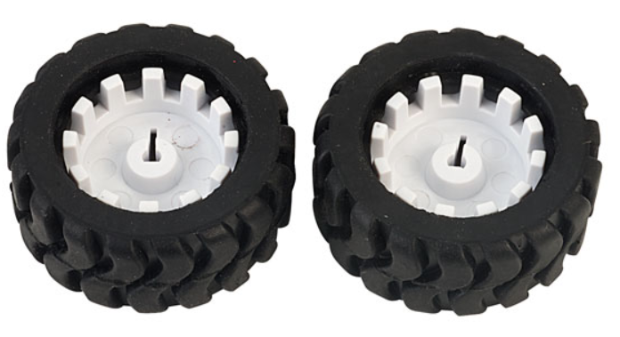

Figure 26 : Pololu Wheels

Test 1 was a motor test. With quick success, we connected the motors straight to our power source, which was a 9V battery, the motor ran at a high speed, by swapping the polarity of the battery we were also able to reverse the direction of the shaft turning.

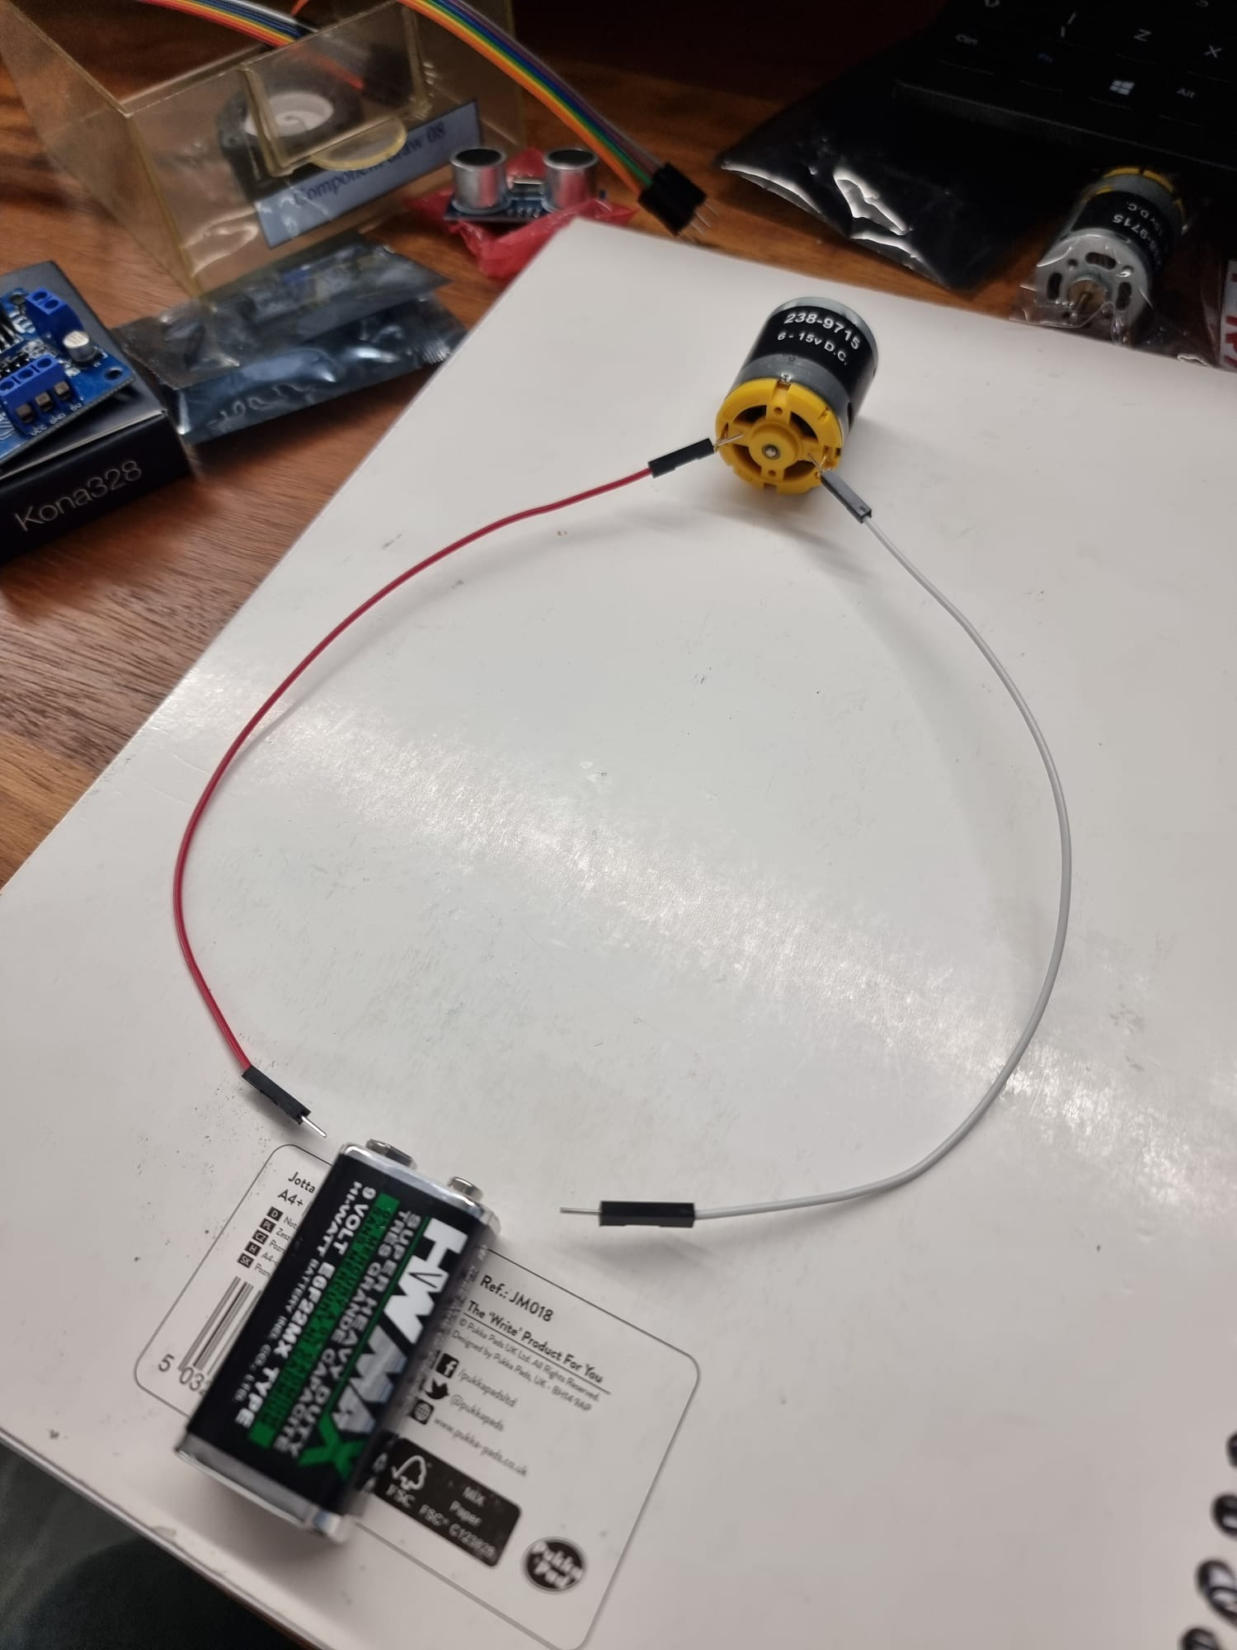

Figure 27 : Test 1 motor test

After Test 1 was a success, we moved onto a more complex test, we mounted the motors to its section of the chassis using a right-angled bracket that we had laser cut, again the modularity of our design showed its benefits because we were able to assemble our motor section without risking harming our Arduino or causing excessive heat to the battery section.

For test 2, we used the motor and wheels in the bracket to test the effectiveness of the chassis. The robot was able to move, ideally in a straight line, however, due to an uneven shaft adhesion on the robot, it tended to lean and move in 1 direction. This was an error in our ordering process. When we saw the difference between the shaft diameter of the motor and the shaft insert diameter of the wheels, we thought we could use friction along with some tape to fill the gap. However, this was fixed by a simple readjustment of the adhesion, we made sure that the tape used to create friction was the same length for both sides.

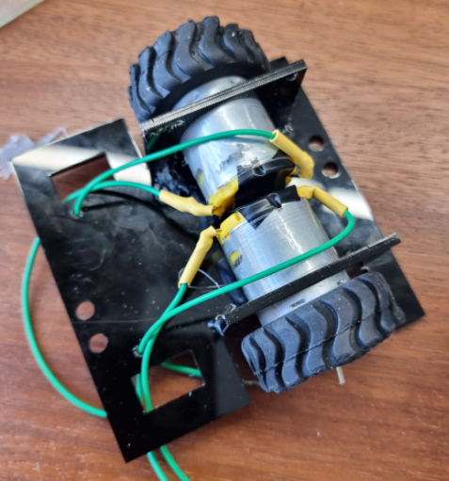

Figure 28 : Motors and wheels attached to skeleton

For test 3 we connected the motors to the L298N and the Arduino, we had to connect 12 different wires in order to allow the motors to move.

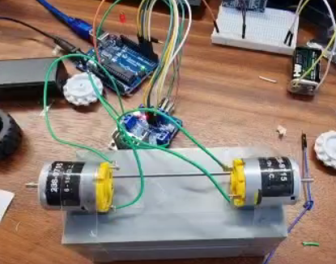

Figure 29 : Motor test 3

We first wrote code that will allow the Arduino to know exactly what is connected to each of its pins. enA and enB are controller pins which take an analogue value from 0-255 and give the sides their allocated voltage, hence increasing or decreasing the speed at which they spin. The integer values indicate which pin of the Arduino they were plugged into.

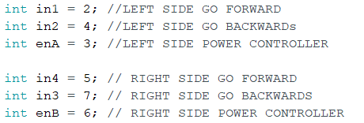

After we declared the pin, we had to declare all these pins as inputs or outputs, there isn’t any data we need to take from the motors, so all the pins are set to output in our Arduino’s setup code, which will run once every time the Arduino is reset.

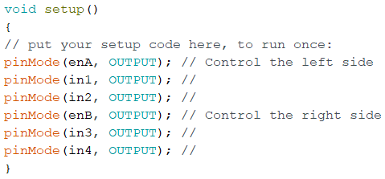

Next, we had to test if the L298N could control our motors to the left we wanted, so our first test was to see if it could make the robot go forward and backwards at different speeds. At first, we ran the robot at a very slow speed, and observed that our wheels ran slowly, but still fast enough to cause the wheels to rotate, we used a multimeter to measure the voltage going to each motor terminal and saw that we had from 1.5-2 volts going to each motor, which was within our expectations.

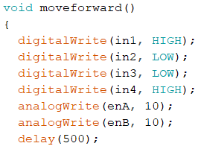

For our next test we increased our enA and enB speeds by 50 until we reached 250, and as expected, the motors got faster and faster with every iteration, when we got to 255, we saw the motor rotate powerful enough to almost cause the chassis to shake apart, we also used the multimeter to observe the voltage drop-off that we expected in the design stages. We were reading a voltage drop off of around 1.5 volts. Due to the destructive force of 255, we decided to limit our robot to 150 for its normal movement.

#### Turning

In order to turn our entire robot whilst moving we knew we couldn’t use an axel system like real cars use, so we settled on only supplying voltage to one side of the robot in an attempt to force it to turn.

Our first observation was that when we gave the right motor power, it causes the entire robot to turn left. This is because the unused wheel acted as a pivot point and anchored that side down. So, we knew that the direction that the motors turn should be the opposite of the direction which we want the robot to move in

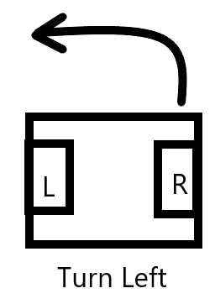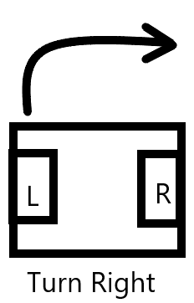 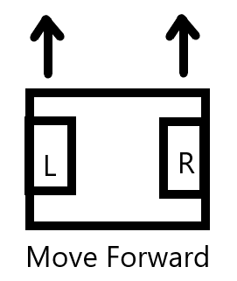 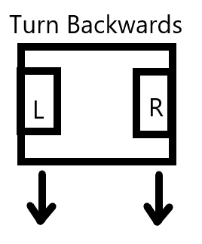

Figure 30 : motor turn tests 1

Another issue we had with turning was what to do with the non-used wheel. We could allow it to just remain stationary, but we observed that it caused turning to take up quite a lot of space, almost equal to the robot’s length.

A member of our team suggested that we allow the two wheels to move opposite to each other. So, if we wanted to go left, the right motor would move forwards whilst the left motor would move backwards.

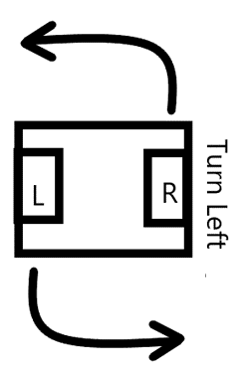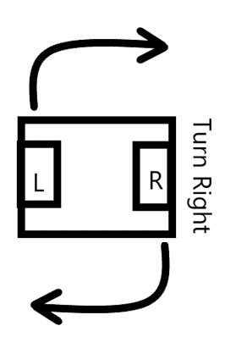

Figure 31 : motor turn tests 2

Using this methodology for our turning, we observed that the distance needed to turn the robot had decreased substantially, the robot was essentially turning on the spot. Which was the outcome that we marked as the best choice.

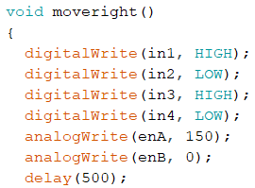

### Testing enemy detection

An important feature of our sumo robot is the ability to sense external objects on the stage and react appropriately, we used the HC-SR04 ultrasonic sensor for this purpose.

The first thing we did when connecting it to the Arduino was declaring its pins, apart from the power wires, the ultrasonic sensor had two pins, an echo pin and a trigger pin. I also declared two global variables in order to store the distance and the time taken for the wave to bounce.

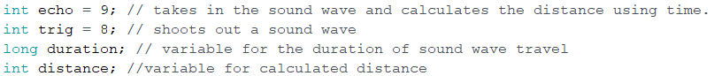

We know that the trigger causes a wave pulse outward, and the echo pin will take that wave and relay the time taken between when the trigger emitted a pulse and when the echo detected a pulse. Due to that, we classify the trigger pin as an output and the echo pin as an input.

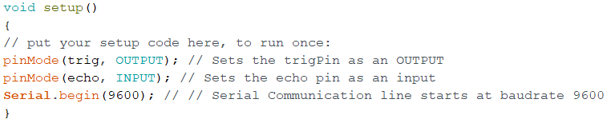

In our loop section of our code, we quickly turn off and on our trigger pin in order to create a wave pulse out of the trigger pin, we will then use the pulseIn() function in order to allow the echo pin to read in the wave and assign the time taken to read into the variable duration, which is a measure of time.

Then using the equation (from design section) we will then calculate the distance using that value and then print it to our serial line.

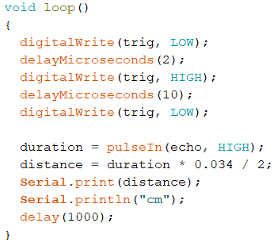

When we received the sensor, we needed to test its accuracy to see if it was a good match for our use case, so we set up a test apparatus of the sensor and a meter ruler. We were going to test the accuracy of the sensor by placing a piece of paper in front of it at a set number of equally spaced distances. From the data sheet we know that the minimum sensing distance of the sensor is 3cm, so I know that the minimum distance to trust is 3cm.

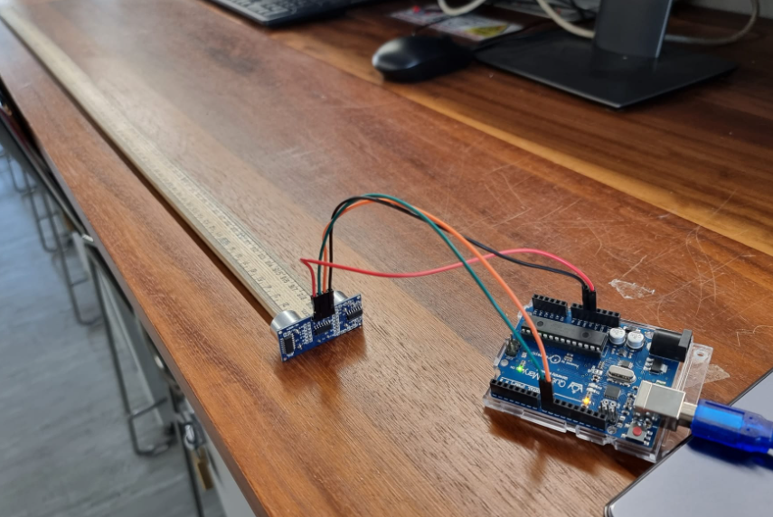

Figure 32 : testing apparatus for ultrasonic sensor

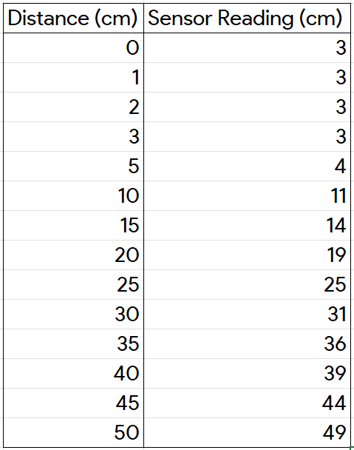 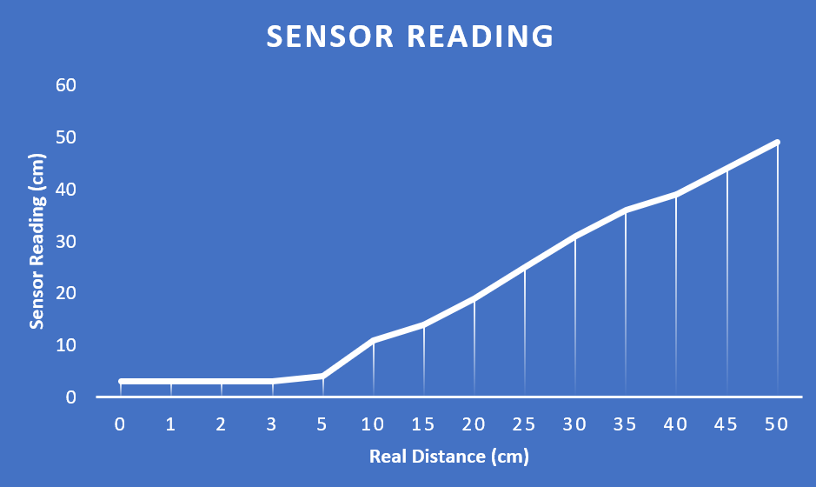

Figure 33 : test data for ultrasonic sensor

The ideal results would have been a straight line, showing parity between our real distance and sensor distance.

The real results from our tests tell us that the sensor is accurate to ± 1cm and that any readings under 3cm should be discarded. One possibility that would have affected the accuracy of our test results is that a human hand was holding the paper, so despite us being careful, natural swaying of the hand could have caused a human measurement error.

The next phase of our ultrasonic testing was when we put it on the stage against a box and observed it reacting. In the code we told the robot that if it detects anything within 15cm that it should charge forward infinitely. I chose 15cm because we know that the diameter of the ring is 77cm, so being able to detect an enemy from a quarter of the stage is good because it means that our robot won’t start pre-emptively moving forward and fall off on its own.

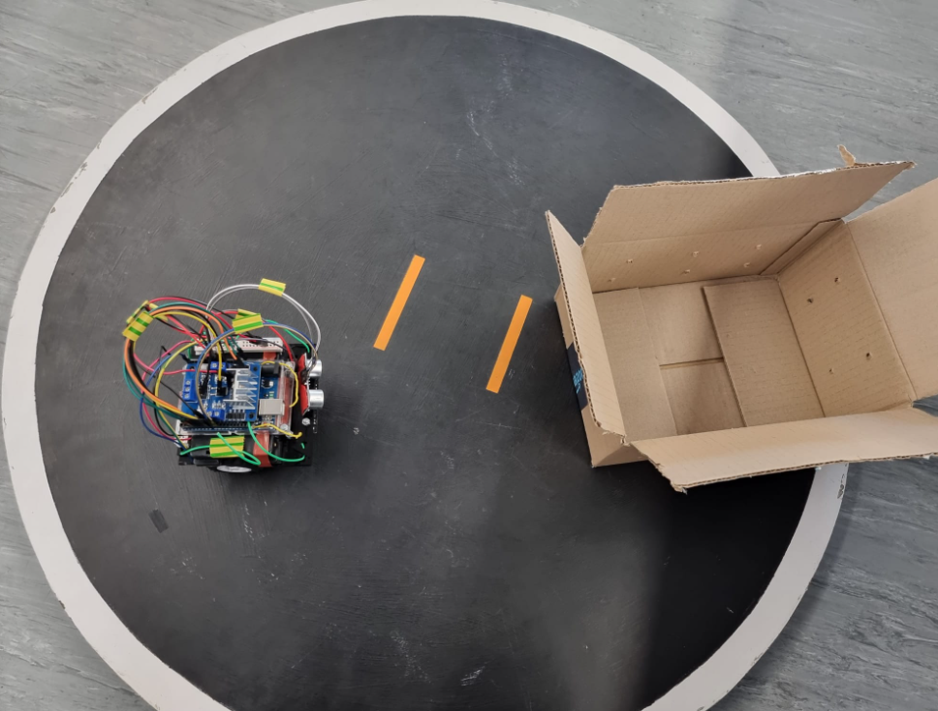

Figure 34 : the robot detects an enemy

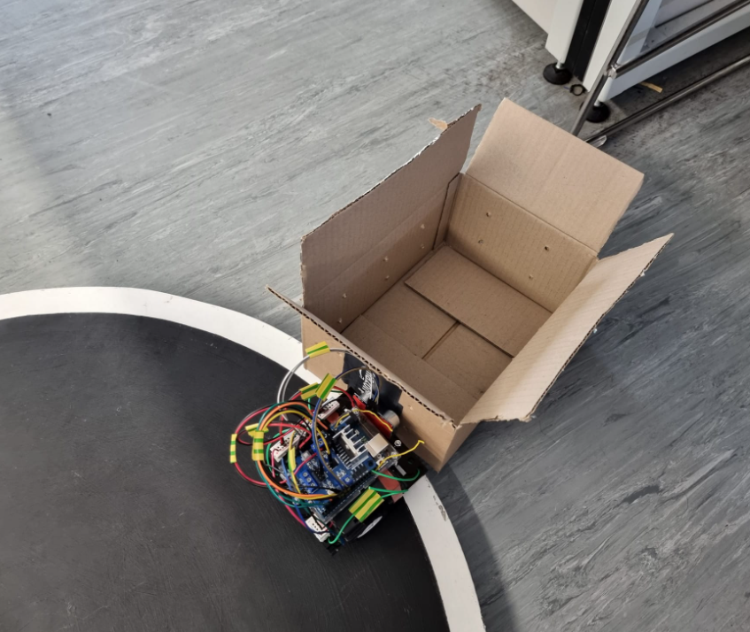

Figure 35 : the robot pushes the box off the stage

From our testing we found that the robot is able to detect enemies on the stage using its ultrasonic sensor and move forward in order to push the enemy off.

### Testing Black and White detection

An essential function of our robot is its ability to stay on the stage, we lose the match if the enemy robot manages to push us off the stage, but we also lose the match if our robot moves off the stage on its own.

The first task we had to do when connecting the Arduino to the sensor was declaring its pin, since we wanted a numerical value from the black and white sensor, we plugged it into the analogue port on the Arduino. I also created a global variable to store the current reading of the sensor.



Then I declared the sensor as an input because I expect to get data from it.

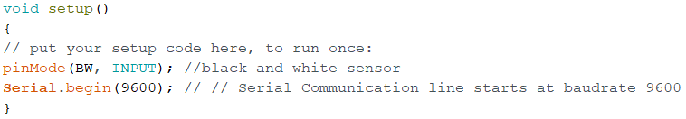

Then in order to get values from the sensor, I analogue read from the sensor and assigned the value to the variable and printed it to the serial line.

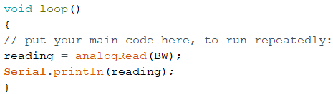

After doing that the sensor was able to relay back to me, numerical values which represented the colours it detected.

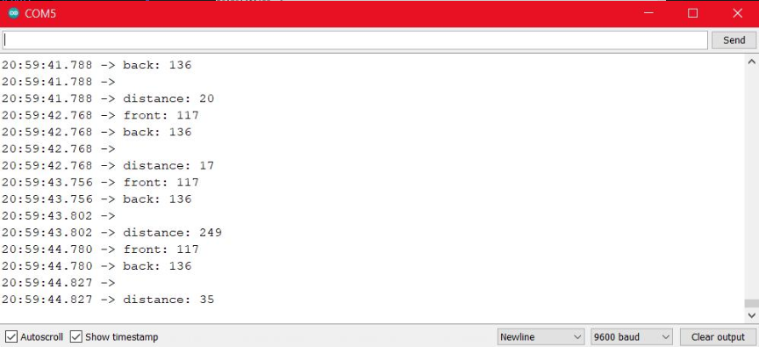

Figure 36 : the raw analogue inputs from the sensors

For the sake of being to understand the serial outputs more easily, I decided that values under 150 would be counted as white, this was to account for any shadows on the underside of the robot.

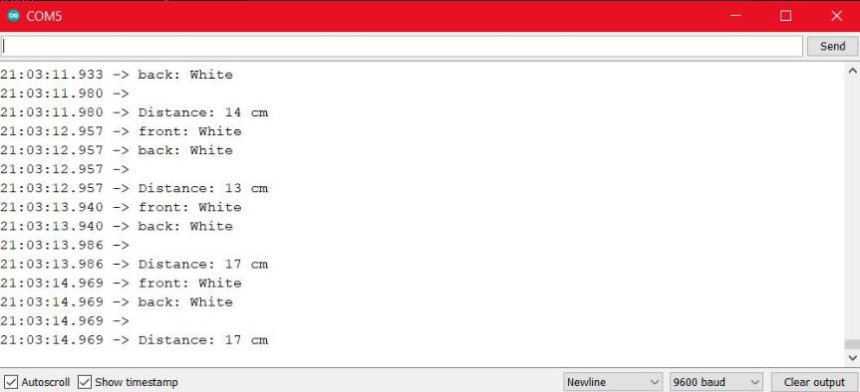

Figure 37 : the processed English input from the sensors

After that, we loaded logic onto the Arduino that told the sensor that if it detected white (at the front) then it should instantly reverse away from it.

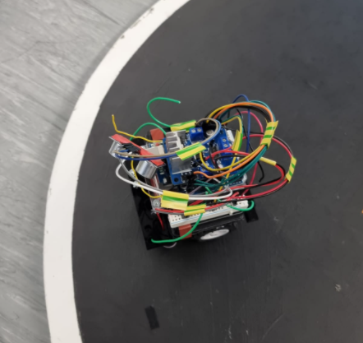

Figure 38 : the robot approaches the white line

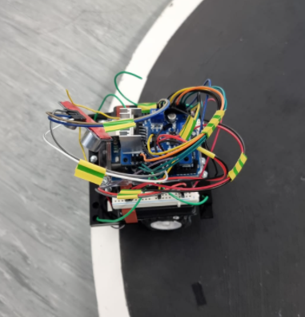

Figure 39 : the robot detects the white border

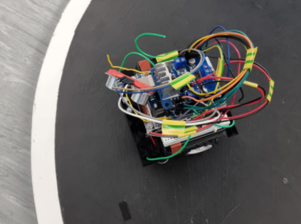

Figure 40 : the robot reverses after sensing the white

From the testing carried out, we agreed that the robot was able to react to the white line accurately and quickly.

Due to the relatively large size of our sumo robot, we needed to use two infrared sensors, one on the back and one on the front. When the front sensor detects white, the robot should reverse and then turn around, When the back sensor detects white, it should just go forward.

### Logic Testing

We first had to convert our flowchart logic into code. After doing so, we uploaded the code to the Arduino and tested it. First of all, we followed the flowchart step by step in order to craft the code, one issue we ran into was taking variables from our functions if we had separate functions for activating the infrared and ultrasonic sensor then we weren’t able to take the values as variables, in order to easily fix this, we added the code to activate the three sensors in the logic code instead of splitting them up in functions.

We tested this code by placing our robot on the stage and using a box to simulate the enemy. We first placed the box in front of the enemy and then slowly brought it closer, when it was 15cm away the robot rapidly accelerated and collided with the box and was constantly pushing the box until the sensor had detected white.

Another test we carried out was we pushed the box into the back of the robot in an attempt to push it out of the ring, when the front had gotten to the white line, the robot tried to reverse which shows that the values in the analogue infrared sensors are being reacted to in the logic.

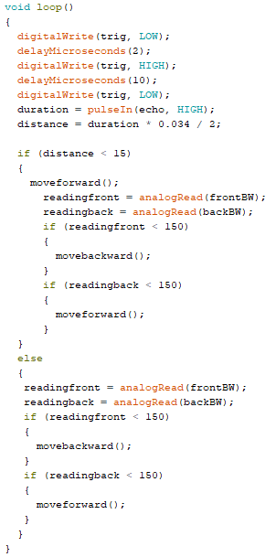

Figure 41 : our logic code

## Critical analysis of results

Throughout this key stage of testing, analyzing and refining work, we faced success and failures in various stages.

Out of the 3 components we tested, its movement was most successful. There were no faults in terms of movement. The construction also proved to be simple.

Tests with regards to the enemy was difficult. Due to a lack of time, limited tests were conducted. Although there was success when detecting opponents and knowing whether to attack or turn its back, distance and size of the opponent caused some issues.

The same issue was faced when detecting the boundaries. Despite being successful in programming the sensors to detect the distance and colour of its boundaries, we initially faced issues with the speed it detected this. However, this was resolved. One test that could not be conducted was how the robot would tackle the opponent near the boundaries – would they be able to push them out and remain within the ring. This could have been seen as an issue if the robot competed in on a larger scale.

### Testing User requirements

We will now test against the user requirements that we specified at the beginning of this project.

#### Weight

The final weight of our robot ended up being 499.72g. This was good because we did not go over the specification limit of 500g, but we also didn’t suffer from being too light, the weight of our robot definitely contributed to our power and stability. But one downside to our weight was our speed, especially compared to some of the smaller competition, our robot was sluggish in its turns and moves. Another issue we faced with weight was that due to us being so close to the weight limit, was that we could not add an external chassis, even a paper cover would have been too heavy, so we fought with exposed wires.

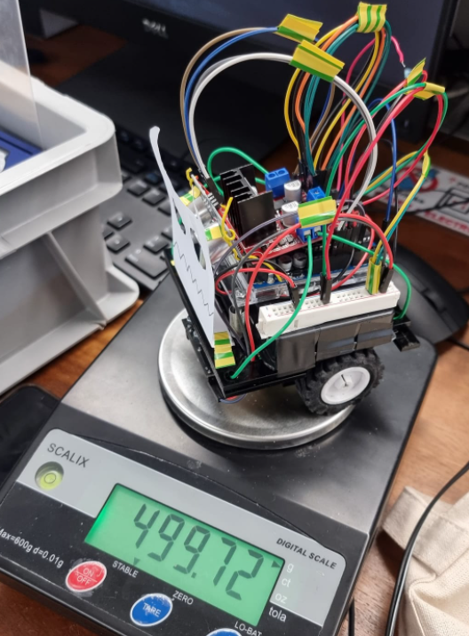

Figure 42 : our robot on a scale

#### Cost

The final cost of our robot was £60.66, although normally saving money would be a good quality, in the context of this project, not being more open with our budget and spending more meant that the components of our project were possibly not the best they could have been. The £39.34 that we had remaining could have contributed to better wheels, or better building qualities, or a more solid 3d-printed chassis.

#### Durability

We are happy with the durability of our robot, our usage of strong, rigid tough 3mm acrylic and metal nuts and bolts meant that it felt solid in the hand and definitely could withstand being attacked by another robot at full speed.

However, one criticism of our durability is that due to the lack of a hood outer chassis, our exposed wires mean that if our robot gets hit from the back or side, a wire might be unplugged, if that wire is a power wire or motor wire, it would cause our robot to completely stop working in the middle of the tournament.

#### Portability and simplicity

We simplified the construction of our robot by making it modular, the Arduino, the motors, and the battery are all completely detachable which meant that our robot was easily transported and diagnosed.

However, one problem, was due to the lack of a top hood chassis, our wires were all exposed, which meant that during transport we had to detach all the wires, this made our robot more complicated because we had to reconnect almost 20 wires to their designated port every time, we transported the robot.

#### Sensors

We are comfortable with the performance of our sensors; we would call our implementation of the infrared colour sensors near perfect at fulfilling their job. However, we would criticize the implementation of our ultrasonic sensor due to its limited angle, to fix this we would have used more of them to increase the effective angle.

#### Preset motions

We were completely satisfied with the preset motions of our robot; it perfectly followed our agreed upon logic chart and showed excellent results in action. The defensive state we chose turned out to work well. The code was able to adequately react to external stimuli and proved to be able to fulfil its operational requirements.

#### Performance

Although the agility of our robot suffered due to its weight, the power and strength we obtained was a good compromised.

#### Size

The size of our robot was within the 10cm x 10cm limit and since we had unlimited height, we just kept building upwards, the stackable skeleton design of our robot showed its benefits when we could easily add more components by adding another layer.

## Analysis of strengths/weaknesses

The success we had was something to take pride of. Example of these successes include robots' mobility, programming, logistics and planning. Due to previous programming experience from previous modules, we faced little problems. Furthermore, well allocated roles enabled us to come over any issues we may have potentially faced.

The researcher helped with regards to wiring components to the Arduino allowing us to not have any issues. Although, we did face an issue with the circuit (short circuit), our construction enabled us to breakdown the chassis and complete a diagnostics test to identify the problem. This one of many examples of the team collaborating well. Throughout the 12-week journey, regular meetings were held allowing us to receive regular updates and keep up with personal and project deadlines.

Unfortunately, as expected, many shortcomings were faced. One of the toughest obstacles was following the weight requirement. Due to lack of thorough weight analysis, a trade off was faced which involved sacrificing our ideal skeleton resulting an increase of how prone the robot was. It also led us to face issues with the components used. Preferably, a larger motor would have been ideal as it would assert higher dominance when pushing opponents off – especially in head-to-head situations.

One of our strengths was our weight, by being as close as possible to the 500g limit, we were more resilient to attacks from all opponents, but especially lighter opponents who used a premade chassis.

One strength that we noticed was that our build quality was more solid than others, we had avoided using glue, and only used nuts and bolts in order to bind our robot together, our chassis was also one solid piece of thick acrylic, so in terms of build quality, I feel as though we were confident.

One shortcoming of our build was mounting the L298N and ultrasonic sensor, due to slight measurement distances we could not directly mount our motor driver and ultrasonic sensor to the Arduino with screws, out of a lack of time and planning, we ended up having to use a semi rigid wire available in the electronics lab to bind the sensor and driver to the top of the Arduino, due to this both components feel “floppy” on the top, however due to the fact that none of those components had any loose wires, unlike the power rail, I felt comfortable making that decision.

The modularity of our robot definitely acted in our favor for this project, for example on the day before the tournament, we had an issue where the motors were not turning at all, by easily disassembling the robot and checking the motor section, we were able to find a short circuit which would have been much harder to find if our robot was permanently held together.

## Possible further work

We are aware is not a perfect model and there are many things that could have been improved. Here in this section, we will be stating some possible things that could be done to improve the robot or change.

### Outer body designs

#### Wall body

We previously used a wall body concept which means a flat front. An advantage of this was that we minimized the area we occupied in the ring. The disadvantage was that for a robot to push an opponent out of the ring it had to push it out vertically hence should have enough speed and strength greater than the opponent but was not the case for this robot as it had only used 2 wheels. A solution would be to add a pair of extra wheels to increase the strength.

#### Ramp

This design of the robot consists of a vertical ramp placed in the front of the robot at an angle of about 45 degrees. The concept of this design is to lift the opposing robot in the ring and possibly their front wheels if they have it, minimizing the speed of the robot making it easier to push out of the ring. A disadvantage of this design is that it is hard for it to execute any defensive maneuvers and will struggle against faster and more agile opponents. We can further improve the robot if it ends up against an opponent which can hold itself even though it is lifted by mechanizing the ramp to move up vigorously flipping the opposing object or robot once lifted.

### Hardware components

#### Using a higher torque motor and wheel combination

Although we aimed to buy and use the best motor and wheel combination we could find, through the tournament we found that others had either bought more powerful motors than us, or better-quality wheels than us. So, if we were to attempt this project again, we would do more research into finding higher power motors, or better-quality wheels.

#### Additional ultrasonic sensors

One glaring issue with our robot sumo was its vulnerability to threats that were not in its direct line of sight. If we had an enemy in our 330° blind spot, we would have no way of detecting the robot even if we were being attacked and pushed out.

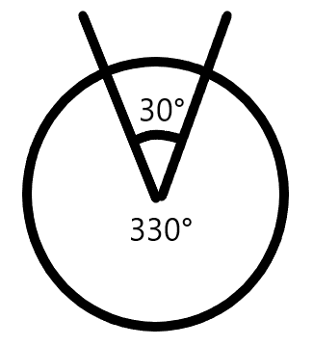

Figure 43 : our robot's line of sight

One potential way we could have fixed this was to use multiple ultrasonic sensors, the more sensors we use, the better our detection would be. Considering that the range of view of our ultrasonic sensor is 30°, by doing 360/30 we would be able to cover all angles of our robot by using 12 ultrasonic sensors in a circular format, although if we were to do that, we would have to upgrade our Arduino from the Uno, to the Arduino Max so that we would have enough input pins to handle the 24 pins that these sensors would require.

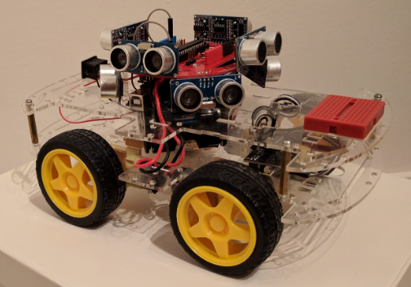

Figure 44 : Robot with a 360-degree ultrasonic range

### Remote-controlled sumo

Instead of making a robot that follows a single program and strategy, we can design a robot that changes strategies mid match with a remote or from an app on a device, by using a simple Bluetooth module, such as the HC-05, would allow us to influence the robot whilst it is running wirelessly, though this would go against the regulations of the Japanese sumo robot competition but still would be useful if we were to evolve the robot concept for real life use, such as a search and rescue robot, or an autonomous surveillance device similar to a drone.

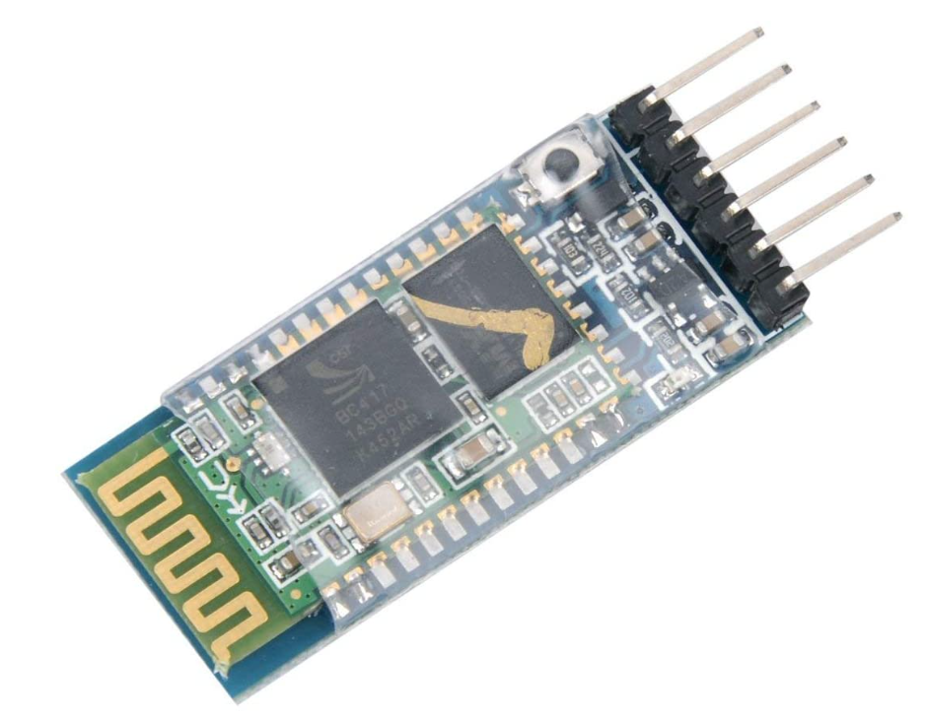

Figure 45 : HC-05 Bluetooth module

# **Sources**

## Research sources

[1] How to Make Arduino Sumo Robot (2022). Available at: https://create.arduino.cc/projecthub/AhmedAzouz/how-to-make-arduino-sumo-robot-f44bd8 (Accessed: 7 April 2022).

[2] How to use the L298N Motor Driver (2022). Available at: https://create.arduino.cc/projecthub/ryanchan/how-to-use-the-l298n-motor-driver-b124c5 (Accessed: 7 April 2022).

[3] In-Depth: Interface L298N DC Motor Driver Module with Arduino (2018). Available at: https://lastminuteengineers.com/l298n-dc-stepper-driver-arduino-tutorial/ (Accessed: 11 April 2022).

[4] Ultrasonic Sensor HC-SR04 with Arduino Tutorial (2022). Available at: https://create.arduino.cc/projecthub/abdularbi17/ultrasonic-sensor-hc-sr04-with-arduino-tutorial-327ff6 (Accessed: 11 April 2022).

[5] [closed], H. and Hass, J. (2013) How do IR sensors detect color?, Electrical Engineering Stack Exchange. Available at: https://electronics.stackexchange.com/questions/94823/how-do-ir-sensors-detect-color (Accessed: 11 April 2022).

[6] Full Visible Spectrum (2022). Available at: https://www.orcagrowfilm.com/Articles.asp?ID=145 (Accessed: 11 April 2022).

[7] outc0000.html (2022). Available at: https://www.fsi.co.jp/sumo-e/out/outc0000.html (Accessed: 12 April 2022).

[8] FSI-ALL JAPAN ROBOT-SUMO TOURNAMENT (2004). Available at: https://www.fsi.co.jp/sumo-e/out/outc0000.html (Accessed: 7 April 2022)

[9] Arduino - Detecting a White Line With The KY-033 (2022). Available at: https://create.arduino.cc/projecthub/vandenbrande/arduino-detecting-a-white-line-with-the-ky-033-927624 (Accessed: 13 April 2022).

[10] SonicDisc: A 360° ultrasonic scanner | Dimitris Platis - Software Engineer & Maker (2022). Available at: https://platis.solutions/blog/2017/08/27/sonicdisc-360-ultrasonic-scanner/ (Accessed: 14 April 2022).

[11] H. and Hass, J. (2013) How do IR sensors detect color?, Electrical Engineering Stack Exchange. Available at: https://electronics.stackexchange.com/questions/94823/how-do-ir-sensors-detect-color (Accessed: 11 February 2022).

[12] J S Cook. Ultrasonic Sensors: How They Work (and How to Use Them with Arduino). Available at: https://www.arrow.com/en/research-and-events/articles/ultrasonic-sensors-how-they-work-and-how-to-use-them-with-arduino (Accessed: 11 February 2022)

System Diagram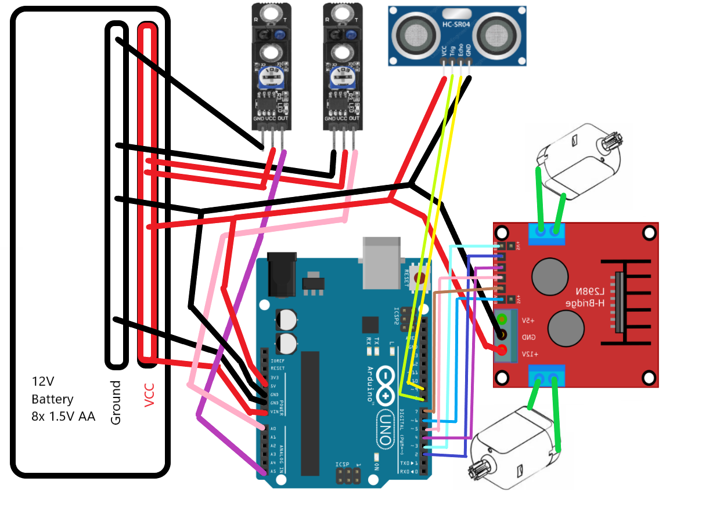

Figure 46 : System Diagrams

## Full Code

1. **int** in1 = 2;
2. **int** in2 = 4;
3. **int** enA = 3;
5. **int** in4 = 5;
6. **int** in3 = 7;
7. **int** enB = 6;
9. **int** echo = 9;
10. **int** trig = 8;
11. **long** duration;
12. **int** distance;
14. **int** frontBW = A0;
15. **int** backBW = A5;
16. **int** readingfront = 0;
17. **int** readingback = 0;
19. **void** setup()
20. {
21. pinMode(enA, OUTPUT);
22. pinMode(in1, OUTPUT);
23. pinMode(in2, OUTPUT);
24. pinMode(enB, OUTPUT);
25. pinMode(in3, OUTPUT);
26. pinMode(in4, OUTPUT);
27. pinMode(trig, OUTPUT);
28. pinMode(echo, INPUT);
29. Serial.begin(9600);
30. pinMode(frontBW, INPUT);
31. pinMode(backBW, INPUT);
32. }
34. **void** loop()
35. {
36. digitalWrite(trig, LOW);
37. delayMicroseconds(2);
38. digitalWrite(trig, HIGH);
39. delayMicroseconds(10);
40. digitalWrite(trig, LOW);
41. duration = pulseIn(echo, HIGH);
42. distance = duration * 0.034 / 2;
43. **if** (distance < 15)
44. {
45. moveforward();
46. readingfront = analogRead(frontBW);
47. readingback = analogRead(backBW);
48. **if** (readingfront < 150)
49. {
50. movebackward();
51. }
52. **if** (readingback < 150)
53. {
54. moveforward();
55. }
56. }
57. }
59. **void** movebackward()
60. {
61. digitalWrite(in1, LOW);
62. digitalWrite(in2, HIGH);
63. digitalWrite(in3, HIGH);
64. digitalWrite(in4, LOW);
65. analogWrite(enA, 150);
66. analogWrite(enB, 150);
67. delay(500);
68. digitalWrite(in1, LOW); // stop
69. digitalWrite(in2, LOW);
70. digitalWrite(in3, LOW);
71. digitalWrite(in4, LOW);
72. analogWrite(enA, 0);
73. analogWrite(enB, 0);
74. delay(500);
75. }
77. **void** moveforward()
78. {
79. digitalWrite(in1, HIGH);
80. digitalWrite(in2, LOW);
81. digitalWrite(in3, LOW);
82. digitalWrite(in4, HIGH);
83. analogWrite(enA, 150);
84. analogWrite(enB, 150);
85. delay(500);
86. digitalWrite(in1, LOW);
87. digitalWrite(in2, LOW);
88. digitalWrite(in3, LOW);
89. digitalWrite(in4, LOW);
90. analogWrite(enA, 0);
91. analogWrite(enB, 0);
92. delay(500);
93. }
95. **void** moveright()
96. {
97. digitalWrite(in1, HIGH);
98. digitalWrite(in2, LOW);
99. digitalWrite(in3, HIGH);
100. digitalWrite(in4, LOW);
101. analogWrite(enA, 150);
102. analogWrite(enB, 150);
103. delay(500);
104. digitalWrite(in1, LOW);
105. digitalWrite(in2, LOW);
106. digitalWrite(in3, LOW);
107. digitalWrite(in4, LOW);
108. analogWrite(enA, 0);
109. analogWrite(enB, 0);
110. delay(500);
111. }
113. **void** moveleft()
114. {
115. digitalWrite(in1, LOW);
116. digitalWrite(in2, HIGH);
117. digitalWrite(in3, LOW);
118. digitalWrite(in4, HIGH);
119. analogWrite(enA, 150);
120. analogWrite(enB, 150);
121. delay(500);
122. digitalWrite(in1, LOW);
123. digitalWrite(in2, LOW);
124. digitalWrite(in3, LOW);
125. digitalWrite(in4, LOW);
126. analogWrite(enA, 0);
127. analogWrite(enB, 0);
128. delay(500);
129. }